LEonard

User Manual





Software Version 22.11.1.0

**LEonard Software by Lecky Engineering, LLC**

|  |  |  |
| --- | --- | --- |
| **Document Version** | **Date** | **Major Additions** |
| 21.11.4.0 | 11/04/2021 | Initial user interface and device management system, Java interpreter |
| 22.04.1.0 | 04/01/2022 | Universal Robot interface and grinding system, LEScript support |
| 22.08.1.0 | 08/15/2022 | LMI Gocator interface and demonstration |
| 22.11.1.0 | 11/14/2022 | Python support, screen sizing and display management |

**CONTENTS**

Overview 7

An aside: LEonard File Structure 7

All About Leonard Devices 7

The LEonardStatement and LEonardMessage 9

LEonard Displays 9

LEonard Programming 10

An Aside: The Print Command 10

LEScript 11

Java 11

Python 12

Theory of Operation 13

The Diagram 13

User Modes 13

System Tabs 14

Run Tab 14

Run Tab- No Options 14

Run Tab- UR Dashboard Connection Only 15

Run - UR Dashboard and Command Connection 16

Universal Robot Option Controls 17

UR Grinding Option Controls 18

Run - UR Dashboard and Command Connection plus LMI Gocator 18

Robot Jogging in LEonard 19

Code Tab 21

Code | Positions 21

Code | Variables 22

Code | Java 23

Code | Python 23

Code | Manual 23

Code | RevHist 24

Setup Tab 25

Setup | Devices 25

Device Types 27

Connect/Disconnect Execution 27

Setup | Displays 27

Setup | Tools 28

Setup | Robot 29

Setup | General 30

Setup | License 31

Logs Tab 31

LEonard Statements 32

LElib Standard Library, All Languages 32

Variables and Data Structures 33

Copying Variables Between LEonard and Java/Python 33

string le_read_var(var_name) 33

le_write_var(string var_name, string value) 33

le_write_sysvar(string var_name, string value) 33

Limited LEScript Variable Handling 33

import_variables(filename) 33

clear() 33

LEScript Assignment 34

LElib.console: Console Control Functions 34

le_print(string message) 34

le_show_console(bool show?) 34

le_clear_console() 34

le_prompt(string message) 34

LElib.log: Logging Functions 34

le_log_info(string message) 34

le_log_error(string message) 34

LElib.flow: Flow Control Functions 35

comments 35

Label_name: 35

jump(string labelName) 35

jumpif(bool condition, string labelName) 35

call(string labelName) 35

callif(bool condition, string labelName) 35

ret() 36

jump_gt_zero(string varName, string label) 36

end() 36

assert(bool condition) 36

sleep(double timeout_s) 36

LElib.device: Device Control Functions 36

device_connect(string device_name) 36

device_connect_all() 36

device_disconnect(string device_name) 36

device_disconnect_all() 36

LElib.UR Library for Universal Robots 37

LElib.UR.dashboard: Commands to control the UR dashboard 37

string ur_dashboard(string message, int timeout_ms) 37

LElib.UR.robot: The UR Robot PolyScope Interface 38

select_tool(string tool_name) 39

set_part_geometry(string FLAT|CYLINDER|SPHERE, double part_diam_mm) 39

save_position(position_name) 39

move_linear(position_name) 39

move_joint(position_name) 39

move_relative(dx_mm, dy_mm) 39

move_tool_home() 40

move_tool_mount() 40

free_drive(0=OFF|1=ON) 40

set_linear_speed(speed_mm/s) 40

set_linear_accel(accel_mm/s^2) 40

set_joint_speed(speed_deg/s) 40

set_joint_accel(double accel_deg/s^2) 40

set_blend_radius(double blend_radius_mm) 40

get_actual_tcp_pose() 40

get_target_tcp_pose() 40

get_actual_joint_positions() 40

get_target_joint_positions() 41

get_actual_both() 41

get_target_both() 41

movej(double j1, j2, j3, j4, j5, j6) 41

movel(double x, y, z, rx, ry, rz) 41

get_tcp_offset() 41

movel_incr_base(double x,y,z,rx,ry,rz) 41

movel_incr_tool(double x,y,z,rx,ry,rz) 42

movel_incr_part(x,y,z,rx,ry,rz) 42

movel_single_axis(axis,value) 42

movel_rot_only(rx,ry,rz) 42

movel_rel_set_tool_origin(double x,y,z,rx,ry,rz) 42

movel_rel_set_tool_origin_here() 42

movel_rel_tool(x,y,z,rx,ry,rz) 42

movel_rel_set_part_origin(x,y,z,rx,ry,rz) 42

movel_rel_set_part_origin_here() 42

movel_rel_part(x,y,z,rx,ry,rz) 43

send_robot(string message) 43

set_output(int port, bool value) 43

robot_socket_reset() 43

robot_program_exit() 43

set_tcp(x,y,x,rx,ry,rz) 44

set_payload(mass_kg,cog_x_m, cog_y_m, cog_z_m) 44

set_door_closed_input(int dig_in, int state) 44

set_footswitch_pressed_input(int dig_in, int state) 44

set_tool_on_outputs(int dig_out, int state, …) 44

set_tool_off_outputs(int dig_out, int state, …) 44

set_coolant_on_outputs(int dig_out, int state, …) 44

set_coolant_off_outputs(int dig_out, int state, …) 44

tool_on() 44

tool_off() 44

coolant_on() 45

coolant_off() 45

LElib.UR.grind: The UR grinding package 45

grind_line(dx_mm, dy_mm, n_cycles, speed_mm/s, force_N, stay_in_contact) 45

grind_line_deg(length_mm, angle_deg, n_cycles, speed_mm/s, force_N, stay_in_contact) 45

grind_rect(dx_mm, dy_mm, n_cycles, speed_mm/s, force_N, stay_in_contact) 45

grind_serp(dx_mm, dy_mm, n_xsteps, n_ysteps, n_cycles, speed_mm/s, force_N, stay_in_contact) 45

grind_poly(circle_diam_mm, n_sides, n_cycles, speed_mm/s, force_N, stay_in_contact) 45

grind_circle(circle_diam_mm, n_cycles, speed_mm/s, force_N, stay_in_contact) 46

grind_spiral(circle1_diam_mm, grind_circle2_diam_mm, n_spirals, n_cycles, speed_mm/s, force_N, stay_in_contact) 46

grind_retract() 46

grind_contact_enable(0=Touch OFF,Grind OFF|1=Touch ON,Grind OFF| 2=Touch ON,Grind ON) 46

grind_touch_retract(touch_retract_mm) 46

grind_touch_speed(touch_speed_mm/s) 46

grind_force_dwell(dwell_time_ms) 46

grind_max_wait(max_time_before_retract_ms) 46

grind_max_blend_radius(grind_blend_radius_mm) 46

grind_trial_speed(trial_speed_mm/s) 46

grind_linear_accel(accel_mm/s^2) 47

grind_point_frequency(point_frequency_hz) 47

grind_jog_speed(trial_speed_mm/s) 47

grind_jog_accel(accel_mm/s^2) 47

grind_force_mode_damping(damping: 0.0 – 1.0) 47

grind_force_mode_gain_scaling(scaling: 0.0 – 2.0) 47

enable_user_timers(integer 0=off, 1=on) 47

zero_user_timers() 47

return_user_timers() 47

LElib.UR.grind Grinding Examples 47

Remove Current Tool 48

Install A Tool 48

Integrated Example 49

Computed Concentric Circles 49

Lots of Grinds 50

LElib.LMI Library for LMI Gocator 53

LElib.LMI.gocator 53

gocator_send(string message) 53

gocator_trigger(int pre_delay_ms) 53

gocator_adjust(int version) 54

gocator_write_data(string filename, string tag_name) 54

Python Library for Gocator 55

start_operation() 55

end_operation() 55

adjust_alignment(int version) 56

offset_to_probe() 56

write_results(string filename, string tag_name) 56

# 

# Overview

Welcome! LEonard is a work cell control system that maintains communication with all the devices in your industrial work cell and allows you to orchestrate their coordinated operation- just like a good orchestra conductor.

LEonard allows you to use write programs in custom LEScript, Java, or Python to write control software and subroutines. The use of Java and Python opens the potential to use millions of lines of pre-existing code, as well as providing you with all the features of these rich programming environments.

LEScript is simpler and basic and is often more than enough for simple work cell coordination and data collection and is less intimidating to those who may not already have familiarity with Javas or Python.

### An aside: LEonard File Structure

LEonard is aware of a <LEonardRoot> directory where it is installed. LEonard expects to be executing out of <LEonardRoot>/LEonard/bin.

For you this could be anywhere. Many customers use c:\LEonard.

Beneath this root, several directories are maintained:

* Code: Where the programs you create will be stored by default
  + Examples: Many LEonard example programs
  + Lib: Python and Java code libraries including custom add-on by Lecky Engineering
* Config: Default location for all of the Devices files *.ldev
* Data: A good default directory for input and output data files
* DB: Leaonard database for Displays, Positions, Tools, and Variables. These are stored as simple XML.
* LEonard/bin: The location of the LEonard executables and support fiiles.
* Logs: Where the logfiles are created.
* 3rdParty: Where example programs for 3rd party devices such as the Universal Robot code and code for the LMI Gocator.

# All About Leonard Devices

LEonard maintains a list of devices that it communicates with. Devices are managed under the **Setup** | **Devices** tab.

Figure LEonard Setup | Devices Screen

Each device has many setup parameters that control how LEonard accesses and communicates with the device.

The device parameters are explained in more detail in Setup | Devices. It is sufficient to know the following:

1. The list of connected devices is stored in a device file. You can have many of these, but most users will need nly one.
2. Each device has a unique ID number and a unique name.
3. Devices can be enabled or disabled… this affects which devices get connected by the **Connect All** button.
4. There are several types of devices:
   1. TCP Server
   2. TCP Client
   3. Serial
   4. Null
   5. Specialty
      1. Universal Robot Dashboard
      2. Universal Robot Command
      3. LMI Gocator Interface
5. Each device sets up a **CallBack**, which is code to handle messages from the device whenever they arrive.

The “general” callback is most common, and is one of LEonard’s key features and tricks!

More information on the specifics of the Devices features of LEonard are available in Setup | Devices.

# The LEonardStatement and LEonardMessage

LEonard relies heavily on the use of a **LEonardStatement**.

When a **LEonardStatement** is analyzed, it is expected to look like one of the following. These are checked in sequence and the first match is handled and the other options untested.

1. filename.js Execute an entire Java file
2. filename.py Execute an entire Python file
3. LE:script Execute any LEScript statement
4. JE:script Execute any Java statement
5. PE:script Execute any Python statement
6. SET varName value. Identical to varName=value
7. GET varName. LEonard reponds with the current value of variable ‘varName’
8. varName = value. LEonard stores ‘value’ into the variable named ‘varName’ for LEScript, Java, and Python

As you can see, external devices can ask LEonard to do very complicated or special things. This is what makes it possible to use LEonard to automate so many work cell scenarios.

A **LEonardMessage** is one or more **LEonardStatements**.

Single: LEonardMessage<TERM>

Double: LEonardMessage<SEP> LEonardMessage<TERM>

Mmore LeonardMessages can be added on.

The advantage of a multiple statement message is that all of the messages will be executed in rapid sequence as a unit.

# LEonard Displays

LEonard was originally is designed to work well on standard 10” industrial touch screen tablets. Butons are large and easy to hit, and special file open and save dialogs, as well as numeric entry, are handled in a touchscreen-friendly way.

However, LEonard can be used successfully on larger monitors. It is also designed to be resizable and to be usable even on big monitors for setup and other purposes.

LEonard provides a standard database of various screen sizes, and you can add your own.

More information on LEonard displays is provided in the Setup | Displays section of the manual

# LEonard Programming

LEonard provides three common programming languages to enable devices to be controlled and sequenced. So how do we do our Hello, World!

Well, let’s first talk about printing to a console screen.

## An Aside: The Print Command

LEonard provides a unified print console for debugging. Show or hide the console with the F12 key.

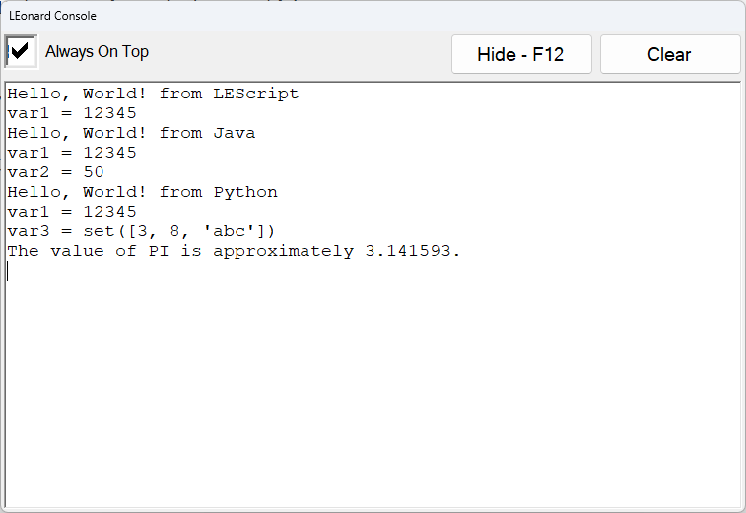

Figure LEonard Console Window

Pressing F12 repeatedly shows and hides the console. It is always receiving and buffering lePrint command data.

The command leShowConsole(true|false) will also show or hide the console and works in any language.

To send data to the print console, use lePrint(message) from any language.

OK, now we can try that Hello, World!

## LEScript

LEScript is a simple scripting language that allows “programming-free” interaction with devices. Most typical work cells can be programmed in LEScript. If you need to compute values or get into deeper calculations or manage data structures, LEonard provides control using either Java or Python, discussed below.

# Hello, World! In LEScript

UsingLEScript()

lePrint(Hello, World!)

value = 13.25

lePrint(value = {value})

Console:

Hello, World!

value = 13.25

An exhaustive list of all the LEScript commands is located in **Appendix 1: LEScript Commands**

## Java

LEonard provides a Java interface with full ECMA 5.1 compliance based on Jint.

Specifications:

Jint Version: 2.11.58

Author: Sebastian Ros

License: <https://raw.githubusercontent.com/sebastienros/jint/master/LICENSE.txt>

Date Published: 11/27/2017

Project URL: <https://github.com/sebastienros/jint>

There are several ways that Java execution can be triggered in LEonard

1. In a LEonard program, commands are interpreted as LEScript until UsingJava() is encountered. Subsequent lines will be executed using Jint.
2. The LEScript command exec_java(filename) will run a Java *.js file as specified.
3. An external device that is using the general callback can return a Java request:
   1. “Filename.js” The specified file will be executed by LEonard::Jint
   2. JE:javascript The specified Java commands will be executed by LEonard
4. The test area in the Code | Java tab. This provides a “sandbox” where Java programs can be created, edited, saved, and retrieved.

# Hello, World! In Java

UseJava()

lePrint('Hello, World!')

value = 13.25 * 8.1

lePrint('value = ' + value)

Console:

Hello, World!

value = 107.32499999999999

## Python

LEonard provides the open-source Iron Python implementation originally developed by Microsoft. This supports Python 2.7 environment and includes the entire standard library. Iron Python support for Python 3 is still in Beta and will be made available upon request if we feel it is stable!

Specification:

IronPython Version: 2.7.12

Author: Iron Python contributors, Microsoft

License: <https://licenses.nuget.org/Apache-2.0>

Date Published: 1/21/2022

Project URL: <https://ironpython.net/>

There are several ways that Java execution can be triggered in LEonard

1. In a LEonard program, commands are interpreted as LEScript until UsingPython() is encountered. Subsequent lines will be executed in Python.
2. The LEScript command exec_python(filename) will run a Python *.py file as specified.
3. An external device that is using the general callback can return a Python request:
   1. Send “Filename.py” The specified file will be loaded and executed in Python.
   2. Send “JE:javascript” The specified Python commands will be executed in Python.
4. The test area in the **Code** | **Python** tab. This provides a “sandbox” where Java programs can be created, edited, saved, and retrieved.

# Hello, World! In Python

UsePython()

lePrint('Hello, World!')

value = 13.25 * 8.1

lePrint(str(value))

import math

var3 = {8, 'abc', 3}

lePrint('var3 = ' + str(var3))

lePrint('The value of PI is approximately {0:.6f}.'.format(math.pi))

Console:

Hello, World!

107.325

var3 = set([3, 8, 'abc'])

The value of PI is approximately 3.141593.

# Theory of Operation

LEonard orchestrates the interoperation of a number of devices using a simple program script that can be written in LEScript, Java, Python, or a combination of all three.

All three languages are provided to make things easier for you! Use what you like.

LEonard executes the main program ***one line at a time***. This permits monitoring, error recovery, and single-stepping.

This maty seem odd to those with a formal Computer Science background, but for reasons of safety and error-recovery, each line of a work cell sequence needs to be handled all on its own.

This also allows single stepping through work cell operations, critical during debug and testing.

Large functions that are safe and which don’t make robots fly around can be built into Java or Python procedures that you load at the start of the LEonard program. This way, you can go fast when you need to, and when the error conditions don’t create unsafe machine situations.

Since LEonard executes Java and Python line-at-a-time in the main run window, creating functions and classes in Java or Python must be done in a separate stand-alone file and loaded in your main program. LEonard provides Java and Python sandboxes for writing and testing standalone code in the **Code | Java** and **Code | Python** tabs.

# The Diagram

# User Modes

There are three user modes. The user mode is selected using the **User** field in the upper-right corner of the **Run** tab.

1. **Operator** mode only permits loading and running existing programs from the **Run** tab. There is no access to the **Code** or **Setup** tabs.
2. **Editor** mode allows access to the **Code** tab to permit editing, but **Setup** is suppressed.
3. **Engineering** mode provides full access to all functions including **Setup**.

Entering Operator or Engineering mode requires a fixed password. By default, these are 9 and 99, respectively.

# System Tabs

In the main LEonard screen, there are four Operation Tabs: **Run**, **Code**, **Setup**, and **Logs**. These screens are described below.

Many functions can be manually activated with buttons or automatically activated with program commands. The convention in this manual is the used boldface for buttons and Tabs and italics for program commands, as in **This Is a Button** and *this_is_a_code_function(param1)*.

The four main tabs will be described below. Here are some quick links if you want to jump!:

Run Tab

Code Tab

Setup Tab

Logs Tab

## Run Tab

The **Run** tab is where the bulk of program execution will typically be observed.

Annunciators and control buttons appear on the Run Tab depending on what options are included and what kinds of devices you are connected to.

### Run Tab- No Options

For example, the raw LEonard screen looks like this, only showing the main program and providing access to Start, Stop, etc.

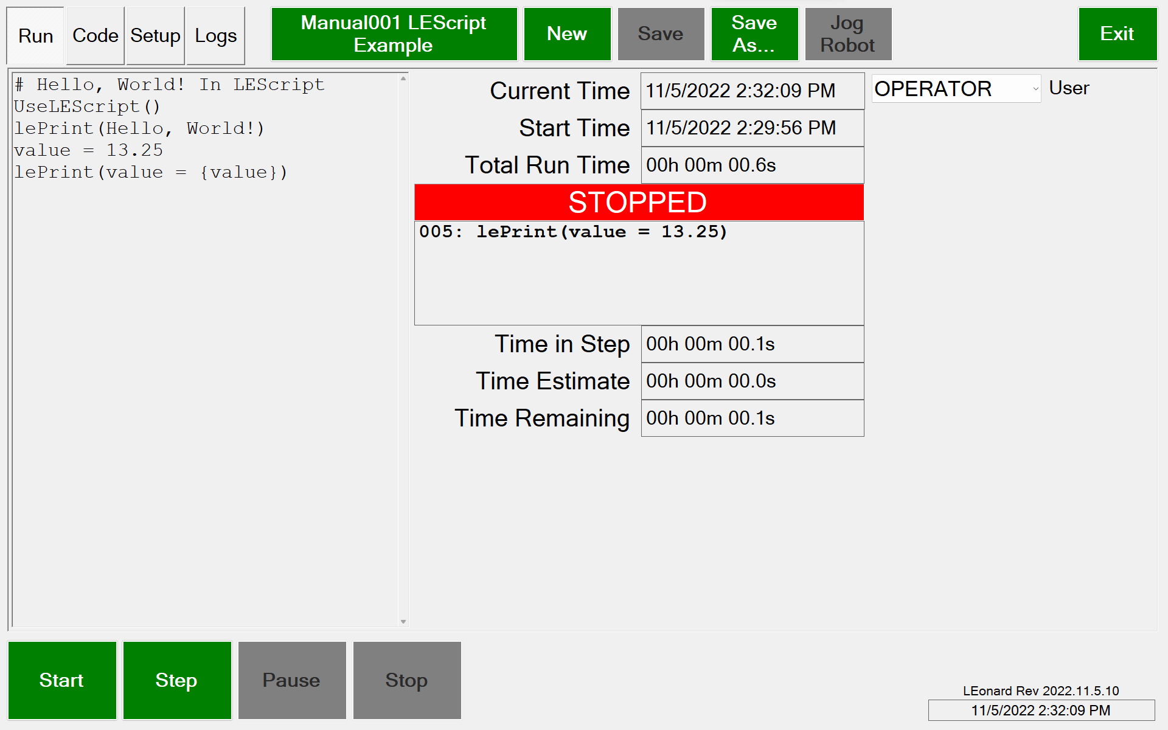

Figure LEonard Run Screen with No Options Installed

A program is loaded using the **Program Name** button next to the **Logs** tab.

Program file operations in addition to **Load** are **New, Save, Save As.**

Set the User in the **User Dropdown.**

### Run Tab- UR Dashboard Connection Only

Connecting a UR Robot Dashboard makes the robot control annunciators visible:

Figure LEonard Connected to UR Dashboard

Figure LEonard Main Screen when Connected to UR Dashboard

**Dashboard OK:** Shows connection status to the Dashboard (this is a TCP client).

**Robotmode:** Press this to cycle from POWER_OFF to BOOTING to IDLE to RUNNING

**Safetystatus:** Press this to clear robot stop conditions

**STOPPED/PLAYING:** Use this to toggle between a PolyScope program running or not on the robot. The program loaded is specified in the Device entry and is shown in this button.

Most of these options require that the UR is in Remote mode.

### Run - UR Dashboard and Command Connection

With a UR Command interface also connected, the full UR control system is available. This requires that a special PolyScope program be installed and running on the robot. This program is provided by Lecky Engineering and can be modified by the user if you need special functions. Contact Lecky Engineering for assistance if you are new to UR programming!

The images below assume the optional UR Grinding package is also licensed.

Figure LEonard Connected to UR Dashboard and UR Command

Figure LEonard Main Screen when Connected to UR Dashboard and UR Command

With the optional Grinding Package enabled we get 2 additional buttons:

**Grind Ready:** Has the current grinding process completed?

**Grind Process:** Are we leaving the tool in contact with the part and expecting the next grind command withing a few seconds?

### Universal Robot Option Controls

**Command Ready:** Shows status of UR Command connection (this is a TCP server).

**Robot Ready:** Shows if the robot is currently executing a LEonard command.

**Command Index Numbers:** Shows index number of last command sent and response ID of last response received. These should stay in lockstep and must be equal to allow the next command to be issued in the program.

Tools are selected in the **Tool Dropdown.** More information on Tools in in Setup - Tools

Part geometry in specified in **Part Geometry Dropdown:** The UR Command program supports surfaces that are FLAT, CYLINDER, or SPHERE

Tools have mount and home positions that can be moved into with the **toolname_mount** and **toolname_home** buttons.

**Running a Program** behaves as expected:

**Start**, **Stop**, **Step**, and **Pause / Continue**

**Jog Robot** is used to jog or freedrive to a defect. Jogging is described on the next page.

### UR Grinding Option Controls

Set the grinding mode with the **Touch/Grind button** which cycles through **No contact, Touch Only, and Touch+Grind**

**Protective Stops:** These show up in (and may be cleared with) the SafetyStatus button

**Door Status** is monitored (IO is configured in the **Setup Tab**). Door Open is treated like **Pause**.

**Footswitch Status** is monitored (IO is configured in the **Setup Tab**).

### Run - UR Dashboard and Command Connection plus LMI Gocator

Adding an LMI Gocator connection reveals the final (for now!) custom buttons:

Figure LEonard Connected to UR Dashboard/Command and LMI Gocator

Figure LEonard Main Screen when Connected to UR Dashboard/Command and LMI Gocator

**Gocator OK:** Is the connection with the Gocator (a TCP client) healthy?

**Gocator Ready:** Goes red when the Gocator is processing.

### Robot Jogging in LEonard

Jogging opens a separate screen. Jogging can be done in **BASE** or **TOOL** coordinates, or relative to a **PART**. The buttons move the robot by the specified increment in Z, XY, or rotation.

Holding a button down (mouse) or double-tapping and holding (tablet) makes the move repeat.

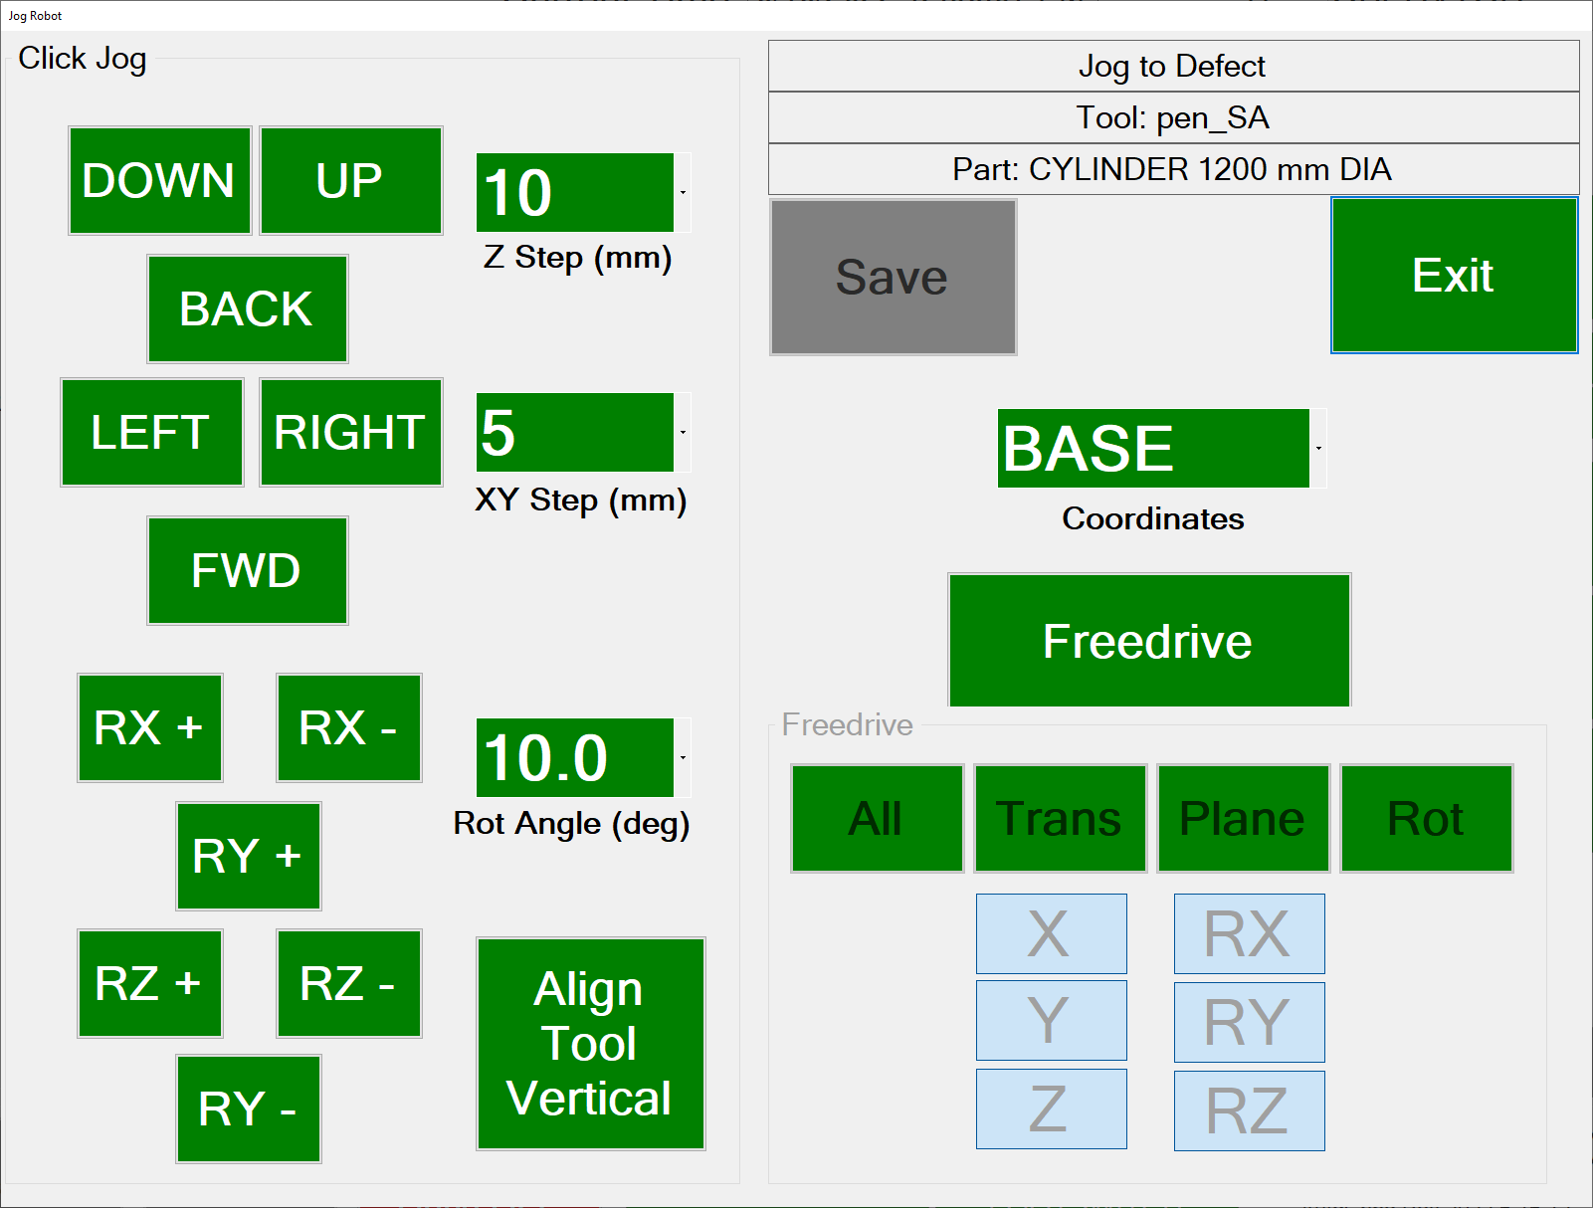

When jogging in **PART** mode, if a cylindrical or spherical geometry is selected, the tool will rotate around the center of the part instead of around the tool tip. This can be convenient for manually jogging to a defect using the touch screen instead of freedrive

Freedrive is supported in a manner identical to on the UR pendant. The X, Y, X, RX, RY and RZ buttons may be used to enable or disable freedrive in any desired axis. All, Trans, Plane, and Rot select pre-defined subsets of axes as on the UR.

Coordinate systems may be changed during freedrive and the tool will allow motion relative to the world, the tool, or the center of the part of part geometry is cylinder or sphere.

Press the Freedrive button again to turn freedrive mode off. Saving or exiting the dialog will also turn off freedrive.

The **Freedrive footswitch** puts all 6 axes in freedrive whether this jog dialog is open or not.

## Code Tab

The **Code Tab** has six subpages: **Positions**, for teaching and manually moving to fixed positions, **Variables**, for monitoring or changing LEonard variables, **Java**, for writing and testing Java programs, **Python**, for writing and testing Python programs,

**Manual,** to provide access to documentation, and **RevHist**, which displays what has been added in each version of the software. The current software version is always displayed in the lower right of the screen.

### Code | Positions

Below is the **Program Tab** when the Positions Subtab is selected.

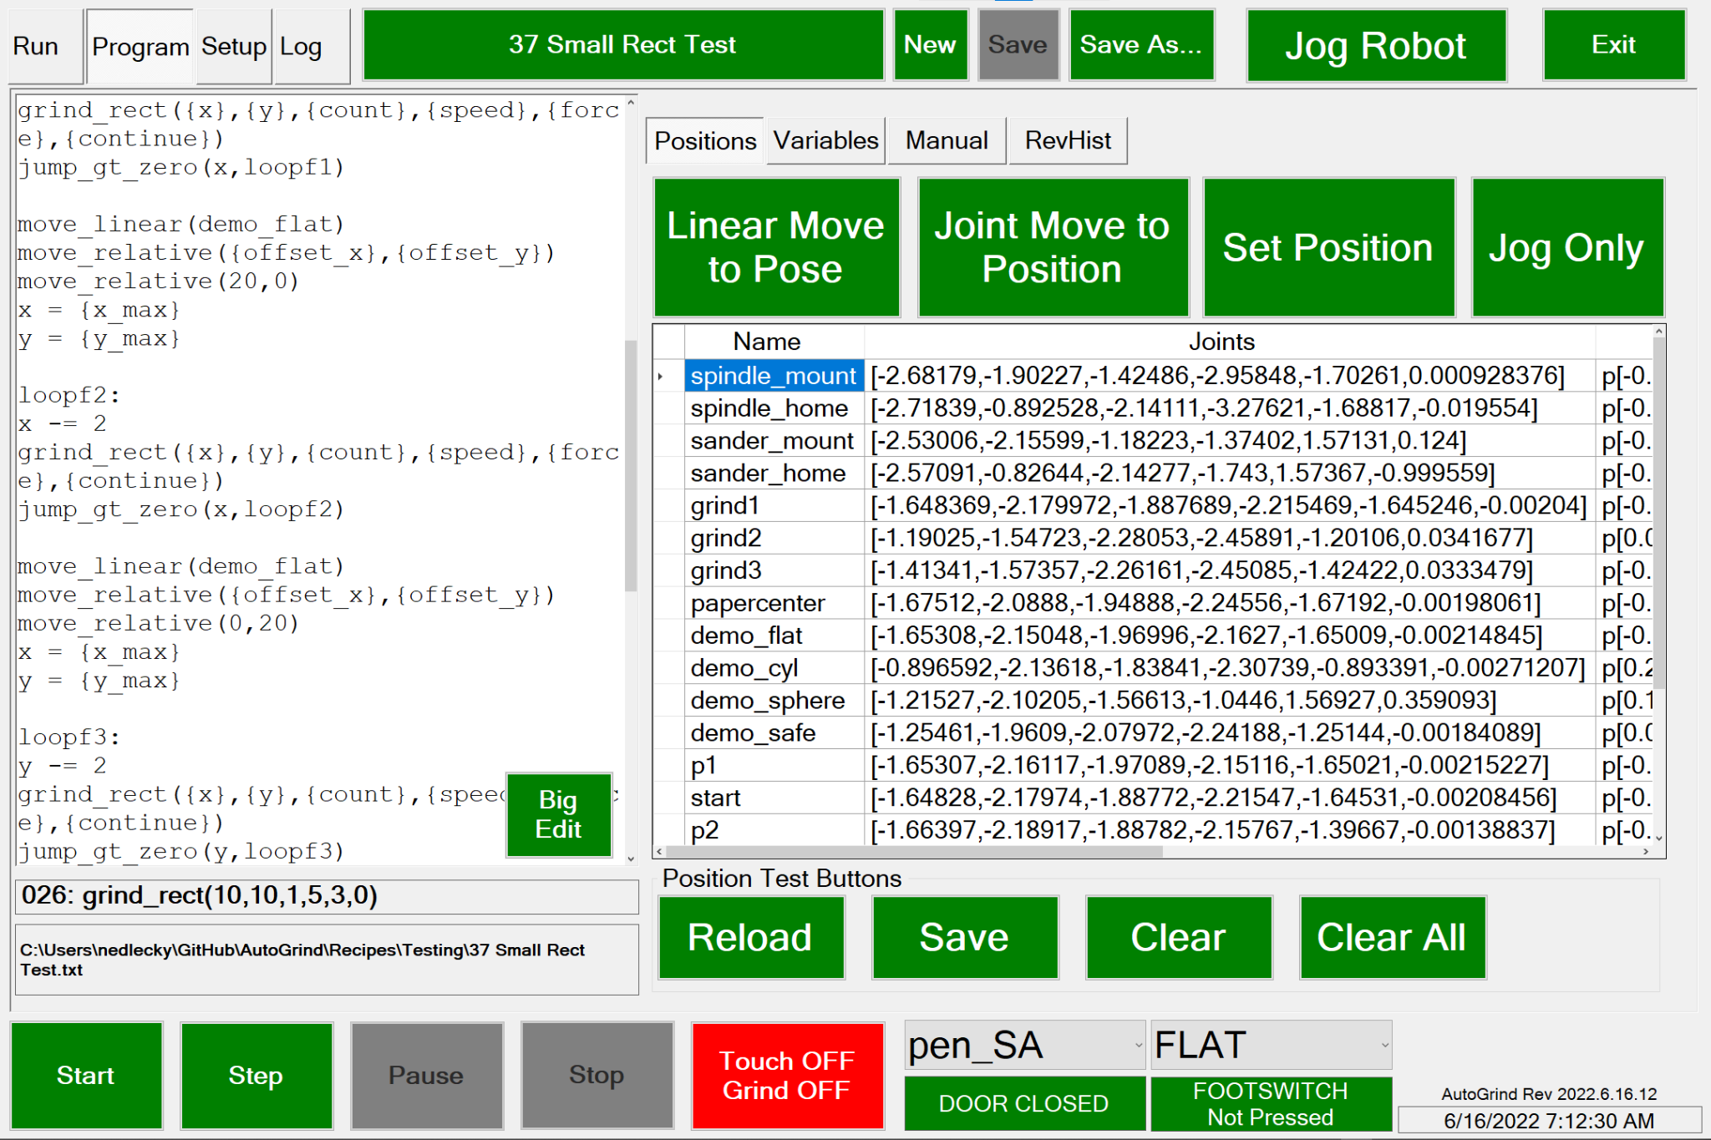

Positions can be saved manually (**Set Position**) or from the recipe with *save_position(name)*.

You can manually move to Positions in Joint (**Joint Move To Position**) or Linear (**Linear Move To Pose**) paths. These can also be executed from a recipe with *move_linear(position)* or *move_joint(position).*

Jogging is used here for setting or updating named positions or just for moving the robot. This uses the standard Jog screen.

**Big Edit** opens up a full-screen editor to make editing complex recipes easier.

### Code | Variables

Below is the **Program Tab** when the **Variables Subtab** is selected..

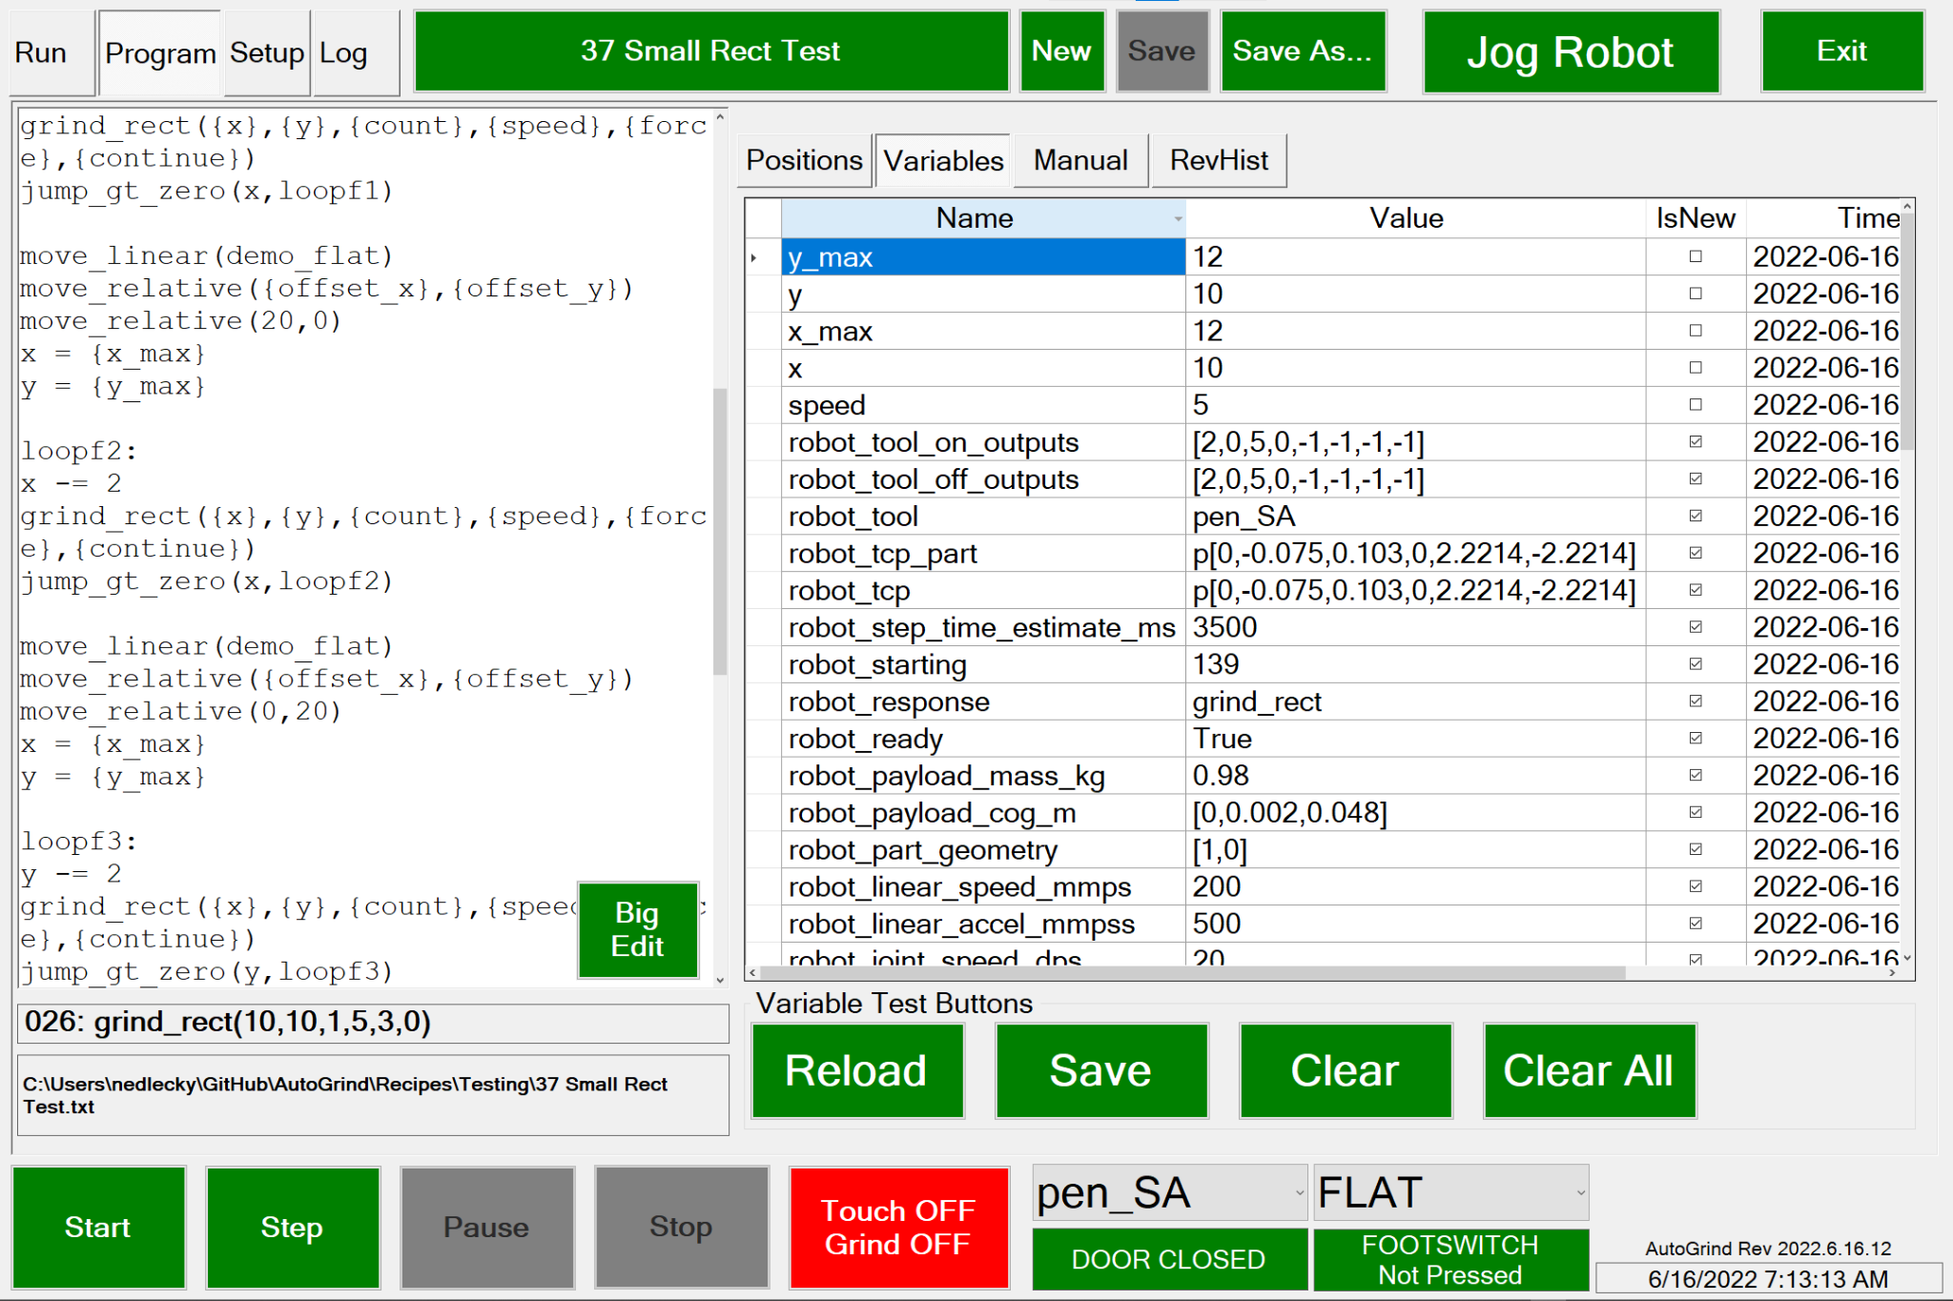

This tab shows all of the local variables maintained in LEonard for internal, system, and user purposes. They can be edited here as well.

System variables will not be erased by the **Clear** button, or by the recipe *clear()* command.

The **TimeStamp** shows when the variable was last written.

**IsNew** indicates whether the variable has ever been examined by the program since the last write.

The variables may be saved or reloaded from Recipes/Variables.xml with the **Save** and **Reload** buttons. Variables are automatically saved on program exit and reloaded when the program starts.

### Code | Java

More here TODO

### Code | Python

More here TODO

### Code | Manual

Below is the **Program Tab** when the **Manual Subtab** is selected..

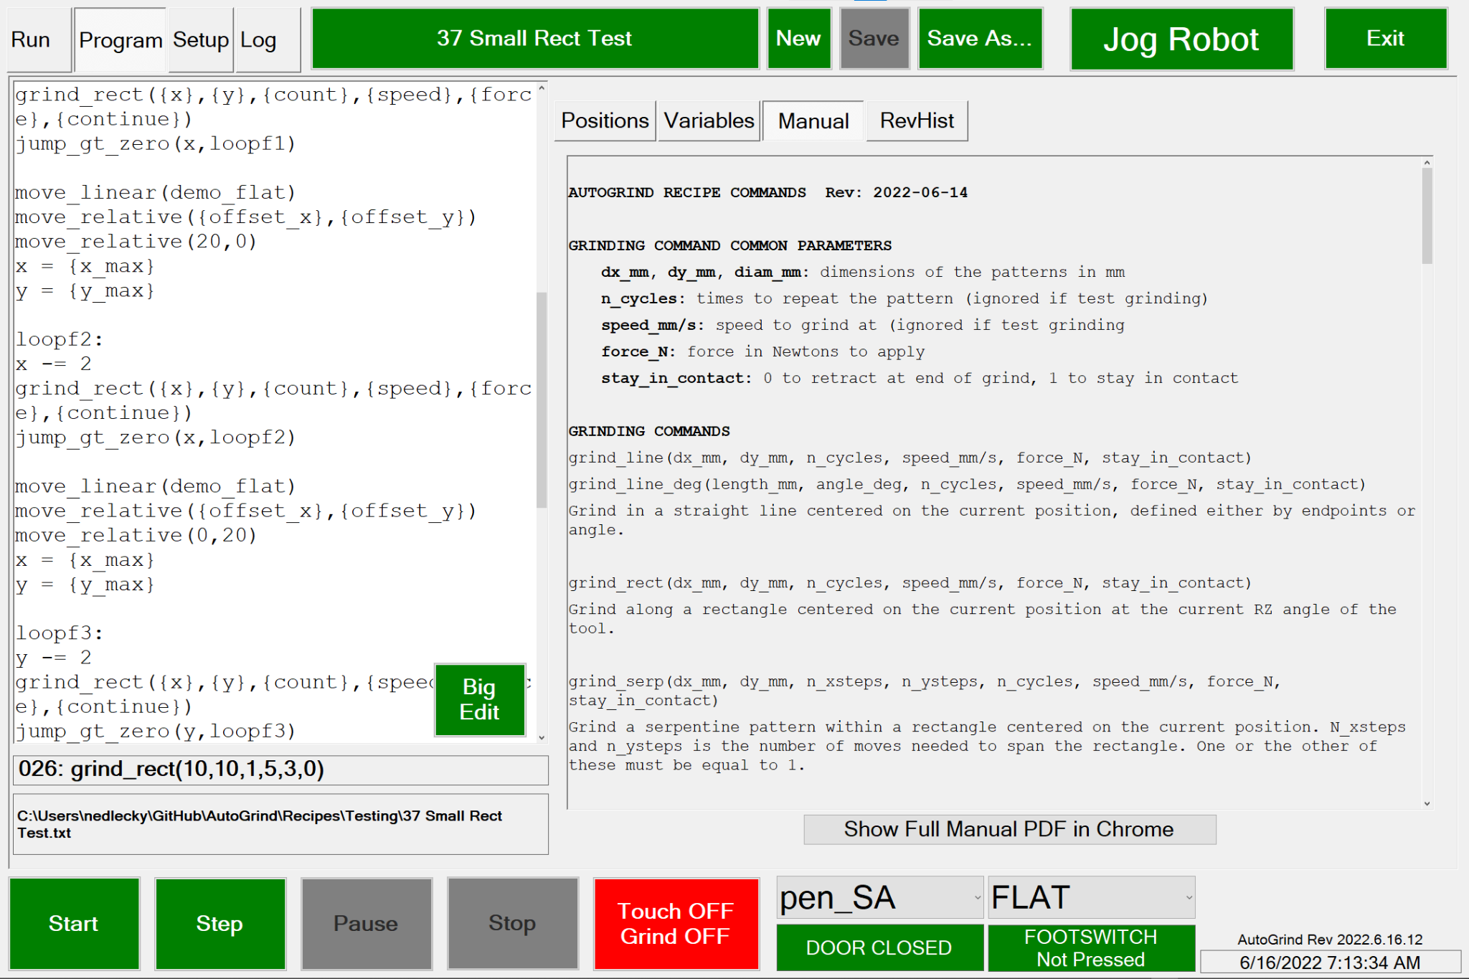

This tab displays the recipe commands to help you remember what each command does and how it is called..

The **Show Full Manual PDF in Chrome** button pulls up a PDF of the manual you are looking at in Chrome. It is assumed that Chrome is installed on the system.

### 

### Code | RevHist

Below is the **Program Tab** when the **RevHist Subtab** is selected..

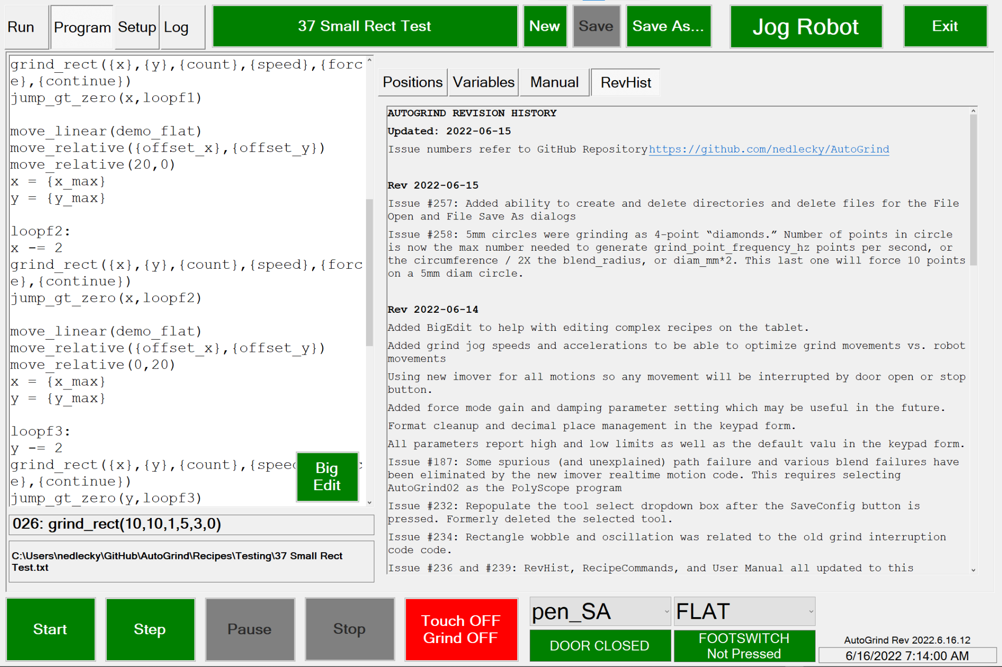

This tab displays the changes incorporated in the current (and prior) versions of the LEonard program. The issues addressed are described in more detail in the LEonard GitHub repository.

<https://github.com/nedlecky/LEonard>

## 

## Setup Tab

The **Setup Tab** is where all system configuration takes place.

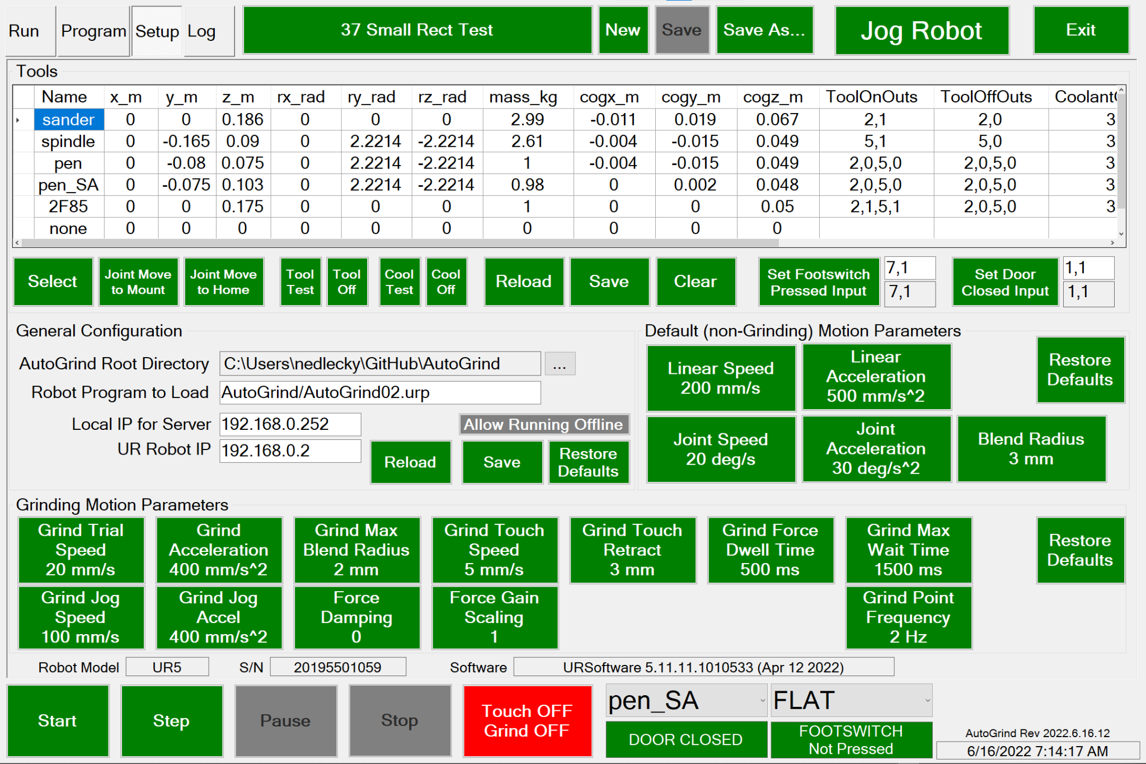

### Setup | Devices

The LEonard device list is a datafile create in the <LEonardRoot/Data> directory. You can have several device files and load different ones for different testing or operational situations.

LEonard devices have the following parameters:

|  |  |  |
| --- | --- | --- |
| Field Name | Type | Description |
| ID | Integer | A unique ID assigned to the device |
| Name | String | A name to help you remember what the device does |
| Enabled | Boolean | Specifies whether the device should be automatically connected by the Connect All button.  Devices are also automatically connected when the device fuile is loaded if **Auto Connect On Load** is enabled in **Setup | General** |
| Connected | Boolean | A boolean value |
| DeviceType | String | One of several classes of devices, discussed below |
| Address | String | Either IP:Port or COMn |
| MessageTag | String | A string to be prepended to log messages to help identify messages from a particular device |
| CallBack | String | A callback function, described below. |
| TxPrefix <PREFIX> | String | A prefix of characters to be sent before each transmission. May include <CR> <LF>, and <CRLF> |
| TxSuffix <SUFFIX> | String | Characters sent at the end of each transmission. May include <CR> <LF>, and <CRLF> |
| RxTerminator <TERM> | String | Characters to be waited for to signify end of received message. May include <CR> <LF>, and <CRLF> |
| RxSeparator <SEP> | String | LEonard will parse (and execute atomically) multiple commands using command<SEP>command<TERM> |
| OnConnectExec | String | When the external device connects, any LEonardMessage specified here will be executed. |
| OnDisconnectExec | String | When LEonard initiates a disconnect, any LEonardMessage specified here will be executed. |
| RuntimeAutostart | Boolean | If true, Runtime Program will be started before connection is attempted. This can be used to start a background server needed by the device for operation. |
| RuntimeWorkingDirectory | String | The Runtime Program will be executed from this directory |
| RuntimeFilename | String | Specifies the filename of the Runtime Program |
| RuntimeArguments | String | Specifies arguments for the Runtime Program |
| SetupWorkingDirectory | String | Some devices have a Setup Program used to configure them, They can be specified here for directory, filename, and arguments |
| SetupFilename | String | Filename of the Setup Program |
| SetupArguments | String | Arguments for the Setup Program |
| SpeedSendButtons | String | If you’d like to be able to send simpe commands for testing to the device, they may be entered here as command1|command2|command3|… A button will be created for each string between vertical bars! |
| JobFile | String | If a device needs to load a specific program to run it can be specified here. This is currently used by UrDashboard and Gocator to start the specified programs at connect time. |
| Model | String | If a device returns a model number, it will be entered here |
| Serial | String | If a device returns a serial number, it will be entered here |
| Version | String | If a device returns a software version number, it will be entered here |

#### Device Types

LEonard device types must be one of the following items:

1. TcpServer Set up a TCP Server on Address:Port and wait for a connection.
2. TcpClient Immediately connect to a device on Address:Port.
3. Serial Connect to a device with Address = COMn using serial protocol over either a hard serial or a USB serial connection
4. UrDashboard: Setup a TCP Client connection to a Universal Robot dashboard server.
5. UrCommand: Setup a TCP Server for a Universal Robot PolyScope program to attach to
6. Gocator: Setup a TYCP Client appropriate for handling commands with an LMI Gocator.
7. Null Connect to nothing… but perhaps use the other features of a device!

#### Connect/Disconnect Execution

Just after a device connects or just before it is disconnected, LEonard can perform an operation.

These operations are encoded in the OnConnectExec and OnDisconnectExec fields in the device.

Any LeonardMessage can be specified. Recall a multi-statement LEonard message can be encoded as:

LEonardMessage = LEonardStatement<SEP>LEonardStatement

### Setup | Displays

LEonard maintains a database of standard display sizes in the Setup | Displays tab, shown below.

Figure LEonard Setup | Displays Screen

All LEonard windows and dialogs are designed to be resizable. Fonts get larger or smaller as necessary. However you arrange the dialog to use it, that is how it will appear the next time you see it.

You can create your own display setting, complete with Width, Height, whether the window is fixed size or resizable, whether it should expand to full screen, and an optional additional Font Scale parameter. The FontScale is applied to the main windows and all LEonard dialogs.

The display database is automatically saved by LEonard, but you can reload the old one if you’ve made a mistake. Clearing the displays will also offer an option to restore these defaults.

Whatever display is selected when LEonard exits will be restored at application startup.

### Setup | Tools

Tools are defined in the Tool Table. Each contains the following information. These are saved in the Tools.xml file in <LEonardRoot>/DB and are loaded and saved automatically.

1. **Tool TCP:** This is a copy of what we would teach for the tool on the UR including x, y, z offset and rx, ry, rz orientation. Teaching these is best done on the UR and then the values simply copied to the entry in LEonard
2. **Mass and Center of Gravity:** Set these as you would on the UR. Accurate settings improves behavior when in freedrive mode.
3. **ToolOnOuts, ToolOffOuts:** This is a list of up to 4 digital IOs that need to be turned on or off to enable the tool. This is only done during a grind in **Touch ON Grind ON** mode. Examples: “1,1,3,1” implies that output 1 should be set to 1 and output 3 should be set to 1. “3,1” implies that output 3 should be set to 1
4. **CoolantOnOuts, CoolantOffOuts:** Similarly, these are digital output commands to be executed when grinding in **TouchOn Grind ON** mode.
5. **MountPosition:** This is a position recommended for installing/removing this tool. The system will use joint moves to approach the position with **Joint Move To Mount** or *move_tool_mount()*. This must be a position that has been defined in the **Positions Table**.
6. **HomePosition:** This is a position recommended for homefor this tool. The system will use joint moves to approach the position with **Joint Move To Home** or *move_tool_home()*. This must be a position that has been defined in the **Positions Table**.
7. **Tool Test,** **Tool Off** and **Cool Test,** **Cool Off**: These allow manually verifying the outputs for the currently selected tool.
8. **Set Footswitch Pressed Input:** This is defaulted to 7,1 meaning that input 7 goes high when the footswitch is pressed.
9. **Set Door Closed Input:** This is defaulted to 1,1 meaning that input 1 goes high when the door is closed.

### Setup | Robot

First, there are settings governing grind operations. These are saved in the Variables.xml file in <LEonardRoot>/DB and are sent to the robot whenever the software starts. New values are saved automatically.

**Grind Trial Speed:** When not in **Touch On Grind On** mode, the grind patterns are limited to one cycle and are performed at this speed.

**Grind Acceleration:** Linear acceleration used during grinding

**Grind Max Blend Radius:** Maximum blend radius used during grinding. Recommended 2 mm

**Grind Touch Speed:** Speed robot advances toward part for touch off. Recommended 5-10 mm/s

**Grind Touch Retract:** Distance robot retracts from part after touch off.

**Grind Force Dwell Time:** How long robot waits after turning force-on to allow time for tool to settle against part

**Grind Max Wait Time:** Maximum time system will wait for the next grind command if a grind command ends with 1 (stay in contact with part)

**Grind Jog Speed:** Linear speed used for all grinding motions that are not in contact with the part other than the actual simulated grind which runs at **Grind Trial Speed.**

**Grind Jog Accel:** Linear acceleration used for all grinding motions that are not in contact with the part.

**Grind Point Frequency:** Used as a minimum frequency for points generated for circles and spirals.

**Force Damping:** May be useful for force mode tuning in the future. Calls the URScript function force_mode_set_damping() with a value between 0 and 1. The default is 0 and that is the only value that has been tested.

**Force Gain Scaling:** May be useful for force mode tuning in the future. Calls the URScript function force_mode_set_gain_scaling() with a value between 0 and 2. The default is 1.0 and that is the only value that has been tested.

Second, there are generally self-explanatory settings for speeds and accelerations used in jogging and non-grinding motion. These are also saved in Variables.xml. New values are saved automatically. **Restore Defaults** sets all to standard values used in all testing.

### Setup | General

1. **LEonard Root Directory:** Location where subdirectories Recipes and Logs will be created. Tools, Variables, and Positions are also stored here in the Recipes subfolder.
2. **Robot Program To Load:** Specifies the program on the UR that the UR will load and run when this software starts. Starting in version 2022-06-07, this should be **AutoGrind/AutoGrind02.urp**
3. **Local IP for Server:** This should be the IP address of the port on the host computer that is connected to the UR
4. **UR Robot IP:** The IP address that the UR is set to
5. **Allow Running Offline:** Testing only… will allow recipes to run with no UR attached

### Setup | License

LEonard uses an encrypted license file that includes information about the CPU, Windows Version it is licensed on, and options that are included in the installation.

Access your license on the **Setup** | **License** tab.

Figure LEonard Setup | License Viewer

Licenses can be perpetual or have a time limit for trial purposes.

A given license file will only work on one CPU and one installation of Windows. Contact Lecky Engineering if you have other needs. We’re very flexible.

Current options are:

* Java
* Python
* Universal Robots Support Package
* Grinding Package for Universal Robots
* LMI Gocator Support

Contact Lecky Engineering to enable features and troubleshoot licensing issues on your system.

## Logs Tab

The Log Tab provides five windows where log messages are displayed. The level of detail in the messages is controlled by the Log Level setting:

* Error: only error messages are shown
* Warn: Error messages and Warnings are shown
* Info: All of the above, plus informational messages about execution. Default setting
* Debug: All of the above plus additional information that may be useful for debugging
* Trace: All of the above plus extremely verbose execution tracing

The All Log Messages box gets 100% of the generated messages. These messages are also written to log files in the <LEonardRoot>/Logs directory, where up to forty 25MB files are archived. Information older than this 2GB total is automatically and silently deleted over time.

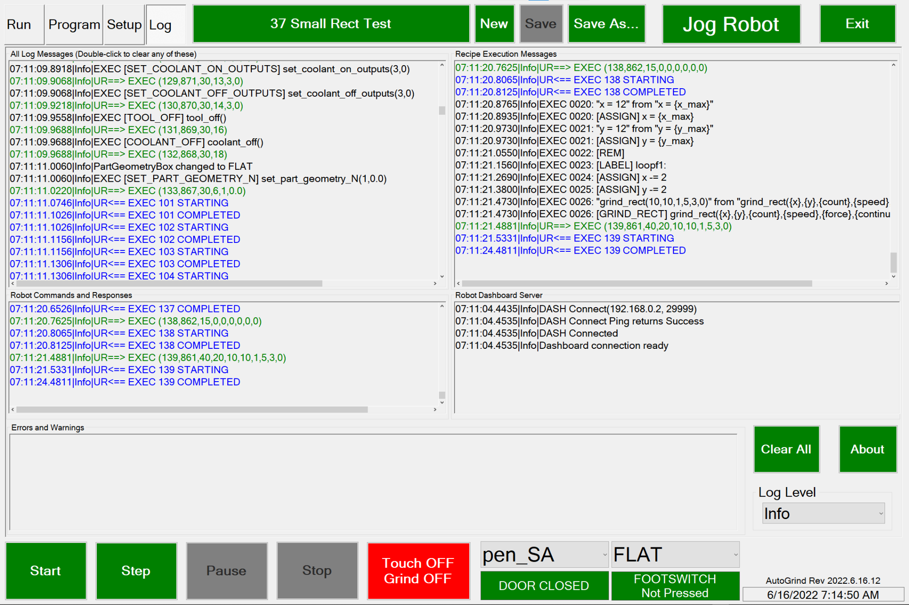

TODO THIS NEEDS UPDATING

In addition, some messages are copied for clarity to other boxes. The boxes are labeled with their respective data: Recipe Execution Messages, Robot Commands and Responses, Robot Dashboard (Control and Monitoring) Messages, and Errors/Warnings.

Any of the boxes can be cleared by double-clicking on them. All boxes can be cleared with **Clear All.** All of the messages are appended to the log files and are archived as described above.

# LEonard Statements

Here is a comprehensive list of all LEonard statements that can be executed by the sequencer.

## LElib Standard Library, All Languages

The LElib Library provides common functions across all three languages.

Where differences exist, they will be highlights with the language matrix shown below.

|  |  |  |
| --- | --- | --- |
| LEScript | Java | Python |
| ? | ? | ? |

### Variables and Data Structures

This is the area where the three languages supported by LEonard differ the most!

For Java and Python, declaring and setting variables, using math, and creating class and structures works as expected in those languages.

Just remember that the sequence executes line-by-line, so any multiline definitions need to be placed in a text file and either imported or loaded.

### Copying Variables Between LEonard and Java/Python

|  |  |  |
| --- | --- | --- |
| LEScript | Java | Python |
|  | x | x |

#### string le_read_var(var_name)

Copies a variable from LEonard to Java or Python. All LEonard variables are stored as strings!

#### le_write_var(string var_name, string value)

Copies a variable from Java or Python to LEonard. All LEonard variables are strings.

#### le_write_sysvar(string var_name, string value)

Copies a variable from Java or Python to LEonard and marks it as a system variable. All LEonard variables are strings.

Read a file and process any lines that contain variable_name = value.

### Limited LEScript Variable Handling

LEScript has a limited set of variable handling capabilities, described below:

|  |  |  |
| --- | --- | --- |
| LEScript | Java | Python |
| x |  |  |

#### import_variables(filename)

Read a file and process any lines that contain variable_name = value.

#### clear()

Deletes all variables except ones that are marked in the Variables Table as system variables. (Variables named robot_* and grind_* are automatically marked as system variables, otherwise you can use le_write_sysvar(name, value) from Java or Python to create them.

#### LEScript Assignment

LEScript supports updating variables using any of these basic operations. Variables can be inserted in any LEScript command using the syntax {var_name}.

var_name = 12.3 var_name = {other_var_name}

var_name++ var_name--

var_name -= 17.5 var_name += 18

### LElib.console: Console Control Functions

#### le_print(string message)

Prints message to the Console Window. For Java and Python, it is also sent to the console test areas in **Code | Java** or **Code | Python** as appropriate. The messages are also logged to the logfile as:

LEScript: LE** message

Java: JV** message

Python: PY** message

#### le_show_console(bool show?)

Hides or shows the Console Window. The console is always open and accumulating any lePrint messages from any language.

#### le_clear_console()

Clears all the text from the Console Window, just like the Clear button in the window itself.

#### le_prompt(string message)

Puts up a dialog box containing message and pauses execution until the operator presses Continue or Abort.

### LElib.log: Logging Functions

#### le_log_info(string message)

Send the message to the logging system as Info. The message will appear in the **Logs** tab and in the logfile.

#### le_log_error(string message)

Send the message to the logging system as Error. The message will appear in the **Logs** tab in red in the Error buffer and will also be sent to the logfile.

### LElib.flow: Flow Control Functions

Flow control in line-by-line execution is implemented differently than it is in the Java or Python standards.

LEonard follows a convention in which lines can be given label names and then jumped to or called. This is consistent with line-by-line execution and is why LEonard is different in the main execution window.

Java and Python functions created in text files operate the way Java and Python always do!

The following sections list each flow control command.

#### comments

Comments in the sequencer are ignored as follows:

1. All blank lines are skipped
2. LEScript and Python statements ignore characters after “#” on any line
3. Java statements ignore any characters after “;” on any line

#### Label_name:

Associates a name with a line in the sequence. Label names are alphanumeric, case-sensitive, and may include the ‘_’ character. Labels are found prior to execution and can be used as targets for jump, jumpif, call, and callif statements. LEScript provides the jump_gt_zero(variable, labelName) function since it does not presently have the ability to evaluate comparison conditions.

#### jump(string labelName)

Causes execution to pass to the line containing labelName:

#### jumpif(bool condition, string labelName)

Performs a jump to the line containing labelName: if condition is true.

#### call(string labelName)

Causes execution to pass to the line containing labelName: Use return to return from the call. Call maintains a return stack (which is cleared when execution begins!) and can nest.

#### callif(bool condition, string labelName)

Performs a jump to the line containing labelName: if condition is true.

#### ret()

Return execution from a call(…) or callif(…) to the line after the one that initiated the call.

#### jump_gt_zero(string varName, string label)

Only available in LEScript since comparisons aren’t available there. Deprecated. Equivalent to jumpif(varName > 0, labelName).

#### end()

Halts execution of the sequencer.

#### assert(bool condition)

Testing support function.

1. In LEScript: used as assert(varName, value). The function checks to see if var_name == value and generates an error message if not.
2. In Python and Java, The function generates an error dialog if condition != True.

#### sleep(double timeout_s)

Causes the sequence to pause for timeout_s seconds. All other operations continue, so this is better to use than the built-in sleep functions in Java or Python!

### LElib.device: Device Control Functions

#### device_connect(string device_name)

Performs the **Connect** function on the specified device. Equivalent to selecting th corresponding row in the **Setup | Devices** table and pressing **Connect**.

#### device_connect_all()

Performs the **Connect** function on all devices in the **Setup | Devices** table that are enabled. Equivalent to pressing **Setup | Devices | Connect All**.

#### device_disconnect(string device_name)

Performs the **Disconnect** function on the specified device. Equivalent to selecting the corresponding row in the **Setup | Devices** table and pressing **Disconnect**.

#### device_disconnect_all()

Performs the **Disonnect** function on all connected devices in the **Setup | Devices** table that are enabled. Equivalent to pressing **Setup | Devices | Connect All**.

## LElib.UR Library for Universal Robots

These functions work with Universal Robots robotic systems. The commands fall into three categories

1. Dashboard
2. Command Interface to Lecky Engineering’s LEonard PolyScope program
3. Grinding Package for force-controlled surface following

### LElib.UR.dashboard: Commands to control the UR dashboard

The UR robot provides a dashboard interface that allows controlling the robot operation.

#### string ur_dashboard(string message, int timeout_ms)

Sends the command message to the currently selected Universal Robot dashboard connection and waits for up to timeout_ms milliseconds for a response.

Response:

LEScript: Any response received is placed in the variable ur_dashboard_response

Java, Python: Function returns any string received or and empty string.

The UR dashboard system provides many commands that are useful in loading, starting, and stopping the robot. The Run tab in LEonard uses robotmode to determine whether the robot has booted, and regularly sends robotmode, safetystatus, and programstate to keep an eye on the robot.

When you press the **Robot Mode** button, LEonard cycles through the robot modes as appropriate- RUNNING initiates sending power off. IDLE initiates sending brake release. And POWER_OFF initiates sending power on. This allows you to cycle through UR operating modes.

The **Safety Status** button sends unlock protective stop and close safety popup when the robot is in safety stop but not in E-Stop.

The **Program State** button toggles between sending play and stop to start and stop the loaded PolyScope program. The UR Dashboard device sends a load JobFile command when the UR connects with the dashboard to get your default PolyScope program loaded.

A comprehensive discussion of the dashboard interface is available on the UR website:

<https://www.universal-robots.com/articles/ur/dashboard-server-e-series-port-29999/>

Here are the most handy ones that are used internally by LEonard!

**Useful UR Dashboard Commands**

get robot model Returns robot model number, as in “UR5”

get serial number Returns robot serial number, for example “20195501xxxx”

PolyscopeVersion Returns PolyScope version installed on robot

power on Power system up

brake release Release from IDLE to READY

load LEonard/LEonard01.urp Load a PolyScope program (default shown)

play Start it

close popup Close a popup prompt on the pendant

close safety popup Close a safety popup prompt on the pendant

unlock protective stop Recover from E-stop or safety stop

stop Stop execution of the program

robotmode Get mode POWER_OFF POWER_ON BOOTING IDLE RUNNING

programstate Return program state STOPPED file PLAYING file

power off Power servos down (and put brakes on)

### LElib.UR.robot: The UR Robot PolyScope Interface

Lecky Engineering supplies an extensive PolyScope program that supports robot control and grinding functions. This code is supplied with the LEonard installation and must be installed on the UR robot.

The LEonard installation comes with a self-installing image that can be placed on a USB thumb drive used to automatically install the programs on your robot. All Lecky Engineering programs will go in a programs/LEonard subfolder on your robot, and your existing robot programs won’t be copied or touched.

***You will likely need to manually open LEonard01.urp on your robot to associate it with the installation file you are using in your installation. You’ll be prompted to select an installation file. Once you do, resave the program and everything should be automatic from there.***

***There is also a set of three hard-coded IP address that the robot looks at to find LEonard. This allows a robot to be directly tied to only one LEonard. You will have to adjust this ni the PolyScope program if your address is something different. Lecky Engineering can help if you need some assistance!***

***The LEonard01.urp PolyScope program currently looks for LEonard on:***

***169.254.254.200:30000***

***169.254.254.210:3000***

***192.168.0.252:30000***

The commands below interact with LEonard01.urp which must be running on your robot.

The default Devices contain an example URDashboard and URCommand device which must be properly setup and connected for the commands below to function. Here’s how they look in the default devices. You will need to adjust them for you IP addresses… in the example,

Robot: 192.168.0.2

Computer running LEonard: 192.168.0.252

Leave the port settings as is: the UR dashboard is always on port 29999 and the default LEonard PolyScope program looks for a server on a specific IP address at port 30000.

**UR Robot Control Commands**

#### select_tool(string tool_name)

Setup all the necessary environment to be able to use tool_name. No motion is performed. Future tool moves, position moves, and grinds will assume this tool is attached.

#### set_part_geometry(string FLAT|CYLINDER|SPHERE, double part_diam_mm)

Future tool moves and grinds will assume the specified geometry.

#### save_position(position_name)

The current robot position is stored in the Positions Table as position_name.

#### move_linear(position_name)

The robot moves along a linear path to Position position_name.

#### move_joint(position_name)

The robot performs a joint move to Position position_name.

#### move_relative(dx_mm, dy_mm)

Move (dx_mm, dy_mm) relative to current tool position. If the part geometry selected is CYLINDER or SPHERE, robot moves along the part.

#### move_tool_home()

Perform a joint move to the home position associated with the current tool.

#### move_tool_mount()

Perform a joint move to the mounting position associated with the current tool.

#### free_drive(0=OFF|1=ON)

Turn robot free drive mode on or off.

The commands below provide a programmatic way to set the default motion parameters.

#### set_linear_speed(speed_mm/s)

Sets default linear speed used for robot linear moves.

#### set_linear_accel(accel_mm/s^2)

Sets default linear acceleration used for robot linear moves.

#### set_joint_speed(speed_deg/s)

Sets default joint speed used for robot joint moves.

#### set_joint_accel(double accel_deg/s^2)

Sets default joint acceleration used for robot joint moves.

#### set_blend_radius(double blend_radius_mm)

Sets default blend radius used in all robot moves.

#### get_actual_tcp_pose()

Ask the current robot to perform get_actual_tcp_pose() and return the value in the LEonard variable actual_tcp_pose.

#### get_target_tcp_pose()

Ask the current robot to perform get_target_tcp_pose() and return the value in the LEonard variable target_tcp_pose.

#### get_actual_joint_positions()

Ask the current robot to perform get_actual_joint_positions() and return the value in the LEonard variable actual_joint_positions.

#### get_target_joint_positions()

Ask the current robot to perform get_target_joint_positions() and return the value in the LEonard variable target_joint_positions.

#### get_actual_both()

Performs both get_actual_joint_positions() and get_actual_tcp_pose() on the current robot and return the values to the LEonard variables actual_joint_positions and actual_tcp_pose.

#### get_target_both()

Performs both get_target_joint_positions() and get_target_tcp_pose() on the current robot and return the values to the LEonard variables target_joint_positions and target_tcp_pose.

#### movej(double j1, j2, j3, j4, j5, j6)

Performs a movej to **joint positions** on the current robot as follows:

q = [j1, j2, j3, j4, j5, j6]

movej(q, a=robot_joint_accel_rpss, v=robot_joint_speed_rps)

#### movel(double x, y, z, rx, ry, rz)

Performs a movel to a **pose** on the current robot as follows:

p = p[x, y, z, rx, ry, rz]

movej(q, a=robot_joint_accel, v=robot_joint_speed)

#### get_tcp_offset()

Ask the current robot to perform get_tcp_offset() and return the value in the LEonard variable tcp_offset.

#### movel_incr_base(double x,y,z,rx,ry,rz)

Ask the current robot to move incrementally from the current position in base coordinates as in URScript:

local p0 = get_target_tcp_pose()

local p1 = p[x,y,z,dx,dy,dz]

local p2 = pose_add(p0, p1)

if p1[0] == 0 and p1[1] == 0 and p1[2] == 0: # Rotational move

movel(p2, robot_joint_accel_rpss, robot_joint_speed_rps)

else:

movel(p2, robot_linear_accel_mpss, robot_linear_speed_mps)

end

#### movel_incr_tool(double x,y,z,rx,ry,rz)

Ask the current robot to move incrementally from the current position in TCP coordinates as in URScript:

local p1 = p[x,y,z,rx,ry,rz]

local p2 = pose_trans(get_target_tcp_pose(), p1)

if p1[0] == 0 and p1[1] == 0 and p1[2] == 0: # Rotational move

movel(p2, robot_joint_accel_rpss, robot_joint_speed_rps)

else:

movel(p2, robot_linear_accel_mpss, robot_linear_speed_mps)

end

#### movel_incr_part(x,y,z,rx,ry,rz)

Ask the current robot to move incrementally from the current position in PART coordinates. X and Y are interpreted based on set_part_geometry(…). For cylinders, X is along the axis of the cylinder and Y is interpreted as a fixed-distance rotation about the cylinder.

#### movel_single_axis(axis,value)

Ask the current robot to move to its current pose with the coordinate axis changed to value.

#### movel_rot_only(rx,ry,rz)

Ask the current robot to move to its current pose with the new rotations rx, ry, and rz.

#### movel_rel_set_tool_origin(double x,y,z,rx,ry,rz)

#### movel_rel_set_tool_origin_here()

Sets a tool-coordinate origin for the current robot either to a specified pose or to the current robot position. Subsequent calls to movel_rel_tool() will move in tool coordinates relative to this origin.

#### movel_rel_tool(x,y,z,rx,ry,rz)

Move to a tool coordinate position that is relative to the movel_rel_set_tool_origin.

#### movel_rel_set_part_origin(x,y,z,rx,ry,rz)

#### movel_rel_set_part_origin_here()

Sets a part-coordinate (FLAT, CYLINDER, or SPHERE) origin for the current robot either to a specified pose or to the current robot position. Subsequent calls to movel_rel_part() will move in part coordinates relative to this origin.

#### movel_rel_part(x,y,z,rx,ry,rz)

Move to a part coordinate position that is relative to the movel_rel_set_part_origin.

#### send_robot(string message)

Sends any command to the Lecky Engineering PolyScope program. All communications with the Lecky Engineering PolyScope program is handled by this command.

1. Commands are sent with a message ID and a checksum as follows:
   1. (ID, checksum, message)
2. ID can be any integer. LEonard sends an incrementing number between 100 and 999.
3. Checksum is expected to be 1000 – ID.
4. message is typically 1 or more comma-separated numeric values.
5. The command is non-blocking.
6. The PolyScope program is expected to send a start message:

robot_starting = ID

robot_ready = False

1. After the command is complete, the PolyScope program is expected to send back the following:

robot_response = response_message

robot_ready=True

robot_completed = ID (as it was received)

In addition, the UR Command device runs the “general” callback, so the UR robot can return **LeonardMessages** to set variables or trigger other actions in LEonard at any time.

#### set_output(int port, bool value)

Set UR digital output port to value.

#### robot_socket_reset()

Commands the Lecky Engineering UR PolyScope program to reset (bounce) its socket connection to LEonard. Program must be running on the UR!

#### robot_program_exit()

Commands the Lecky Engineering UR PolyScope program to terminate. Program must be running on the UR!

Low-level Setup Calls

These are all called automatically by select_tool(), set_part_geometry(),and the grind_xxx() functions. They should be used through that high level interface except during testing or for special purposes!

#### set_tcp(x,y,x,rx,ry,rz)

Executes set_tcp(p[x,y,z,rx,ry,rz]) on the current robot only if x > 10. Always returns the current get_tcp_offset() in the LEonard variable robot_tcp.

#### set_payload(mass_kg,cog_x_m, cog_y_m, cog_z_m)

Executes set_paylod(mass_kg, [cog_x_m, cog_y_m, cog_z_m]) on the current robot only if mass_kg > 0. Always returns the current robot_payload_mass_kg and robot_paylod_cog_m in corresponding LEonard variables.

#### set_door_closed_input(int dig_in, int state)

Specifies what digital input and state is expected to signify that the door is closed to the current robot.

#### set_footswitch_pressed_input(int dig_in, int state)

Specifies what digital input and state is expected to signify that the footswitch is pressed on the current robot.

#### set_tool_on_outputs(int dig_out, int state, …)

Sets a set of digital output,state pairs (1 – 4) to specify what outputs should be controlled when tool_on() is executed on the current robot.

#### set_tool_off_outputs(int dig_out, int state, …)

Sets a set of digital output,state pairs (1 – 4) to specify what outputs should be controlled when tool_off() is executed on the current robot.

#### set_coolant_on_outputs(int dig_out, int state, …)

Sets a set of digital output,state pairs (1 – 4) to specify what outputs should be controlled when coolant_on() is executed on the current robot.

#### set_coolant_off_outputs(int dig_out, int state, …)

Sets a set of digital output,state pairs (1 – 4) to specify what outputs should be controlled when coolant_off() is executed on the current robot.

#### tool_on()

Performs the tool_on output list set in set_tool_on_outputs() on the current robot.

#### tool_off()

Performs the tool_off output list set in set_tool_off_outputs() on the current robot.

#### coolant_on()

Performs the coolant_on output list set in set_coolant_on_outputs() on the current robot.

#### coolant_off()

Performs the coolant_off output list set in set_coolant_off_outputs() on the current robot.

### LElib.UR.grind: The UR grinding package

The grinding commands use a set of common parameters described below:

dx_mm, dy_mm, diam_mm**:** dimensions of the patterns in mm

n_cycles**:** times to repeat the pattern (ignored if test grinding)

speed_mm/s: speed to grind at (ignored if test grinding

force_N: force in Newtons to apply

stay_in_contact: 0 to retract at end of grind, 1 to stay in contact

#### grind_line(dx_mm, dy_mm, n_cycles, speed_mm/s, force_N, stay_in_contact)

#### grind_line_deg(length_mm, angle_deg, n_cycles, speed_mm/s, force_N, stay_in_contact)

Grind in a straight line centered on the current position, defined either by endpoints or angle.

#### grind_rect(dx_mm, dy_mm, n_cycles, speed_mm/s, force_N, stay_in_contact)

Grind along a rectangle centered on the current position at the current RZ angle of the tool.

#### grind_serp(dx_mm, dy_mm, n_xsteps, n_ysteps, n_cycles, speed_mm/s, force_N, stay_in_contact)

Grind a serpentine pattern within a rectangle centered on the current position. N_xsteps and n_ysteps is the number of moves needed to span the rectangle. One or the other of these must be equal to 1.

#### grind_poly(circle_diam_mm, n_sides, n_cycles, speed_mm/s, force_N, stay_in_contact)

Grind along a polygon of n_sides inscribed in circle_diam_mm centered on the current position.

#### grind_circle(circle_diam_mm, n_cycles, speed_mm/s, force_N, stay_in_contact)

Grind along a circle centered on the current position.

#### grind_spiral(circle1_diam_mm, grind_circle2_diam_mm, n_spirals, n_cycles, speed_mm/s, force_N, stay_in_contact)

Grind along a variable diameter circle centered on the current position. The circle goes from the first diameter to the second in n_spirals full revolutions.

#### grind_retract()

Ensure not in contact with the part. Happens automatically if a non-grind command is sent, if stop or pause is selected, or if grind_max_wait timer expires.

#### grind_contact_enable(0=Touch OFF,Grind OFF|1=Touch ON,Grind OFF| 2=Touch ON,Grind ON)

Set the grinding mode programmatically as shown.

The commands below provide a programmatic way to set the grinding parameters.

#### grind_touch_retract(touch_retract_mm)

Set grind retract speed used after touchoff.

#### grind_touch_speed(touch_speed_mm/s)

Set speed used to go in for touchoff in Z.

#### grind_force_dwell(dwell_time_ms)

A dwell time performed when force mode is turned on to allow the robot to settle against the grind surface.

#### grind_max_wait(max_time_before_retract_ms)

If the tool is left in contact with the surface awaiting the next grind command, it will retract if this timeout is exceeded.

#### grind_max_blend_radius(grind_blend_radius_mm)

Sets the maximum blend radius that will be used in any pattern. This will be reduces for small geometries.

#### grind_trial_speed(trial_speed_mm/s)

Sets the speed used for “air grinding” when not in Touch + Grind mode.

#### grind_linear_accel(accel_mm/s^2)

Sets the linear acceleration used for grinding operations.

#### grind_point_frequency(point_frequency_hz)

Sets a point interpolation frequency used for complex figures. Obsolete.

#### grind_jog_speed(trial_speed_mm/s)

Sets the speed used when the grinding requires a robot move while not in contact with the part.

#### grind_jog_accel(accel_mm/s^2)

Sets the acceleration used for grinding m,oves not in contact with the part.

#### grind_force_mode_damping(damping: 0.0 – 1.0)

Sets the UR force_mode_damping parameter to assist in stabilizing force-mode performance.

#### grind_force_mode_gain_scaling(scaling: 0.0 – 2.0)

Sets the force_mode_gain_scaling parameter to assist in stabilizing force-mode performance.

**Grind User Timers: Internal Use**

Enabling these will time each grind operation and place it in a circular buffer of user_timers that can be returned to the variable list with return_user_timers(). Used primarily for internal testing.

#### enable_user_timers(integer 0=off, 1=on)

Turn the UR-internal user timers on or off.

#### zero_user_timers()

Zero all UR-internal user timers.

#### return_user_timers()

Return an array of timers. Each timer represents one grinding operation. Repeating the same grinding operations on different surface geometries can be used to validate Lecky Engineering’s internal speed calibration system.

### LElib.UR.grind Grinding Examples

Here are a few sequences that show the kinds of things that can be done in a recipe. The Examplessubdirectory in the Code folder has many more complicated examples that you can examine (and run!).

These examples are shown in LEScript and require slight edits in Java or Python sequences.

#### Remove Current Tool

Just remove the current tool from the robot. As long as the one actually mounted is selected, this goes to the tool home followed by the mount/demount position and prompts the operator when it is time to remove.

# Remove Current Tool

# Go through demount procedure

# Assumes you have selected whatever tool is actually mounted!

prompt(Please confirm: you wish to demount {robot_tool}?)

move_tool_home()

move_tool_mount()

prompt(Please demount tool {robot_tool})

select_tool(none)

#### Install A Tool

This goes through prompting to mount a specific tool.

# Install 2F85

# Example to install a tool when none is currently installed

# We just select the new tool, move to the mount position, prompt the operator, and move to tool_home

# Change to whatever tool you like

tool=2F85

# Operator confirmation

prompt(About to mount {tool})

# Mounting process

select_tool({tool}) # This only informs the robot what is mounted

# This does the physical swap

move_tool_mount()

prompt(Please mount tool {tool})

move_tool_home()

#### Integrated Example

Here we start with the 2F85 tool ready to grind and swap tools and continue from the same location mid-recipe.

# Integrated Example

# Assumes we're where we want to grind initially but need to do a tool swap mid-way

tool1=2F85

tool2=vertest

# Program assumes we are starting with tool1- verify internally and with operator!

assert(robot_tool,{tool1})

prompt(Confirming tool {tool1} is currently mounted and you are grinding on {robot_geometry})

# This will always be our grind_start position

save_position(grind_start)

# Do some grinding with tool1

move_linear(grind_start)

grind_rect(30,30,3,10,10,1)

grind_rect(20,20,3,10,10,1)

prompt(Ready to swap {tool1} to {tool2}?)

# Remove {tool1}

move_tool_home()

move_tool_mount()

prompt(Please remove {tool1})

# Install {tool2}

select_tool({tool2})

move_tool_mount()

prompt(Please install {tool2})

move_tool_home()

# Do some grinding with tool2

move_linear(grind_start) # Returns us to the starting position

grind_rect(30,30,3,10,10,1)

grind_rect(20,20,3,10,10,1)

#### Computed Concentric Circles

Here’s a test recipe that grinds 3 concentric circles explicitly and in a loop, not lifting until the final one.

# 26 Concentric Circle Test

# Old school

grind_circle(30,2,0.9,10,1)

grind_circle(20,2,0.9,10,1)

grind_circle(10,2,0.9,10,0)

# Do it with a loop

size = 30

count = 2

speed = 0.9

force = 10

repeat:

grind_circle({size},{count},{speed},{force},1)

size -= 10

jump_gt_zero(size,repeat)

#### Lots of Grinds

By pre-teaching points and swapping geometries, a whole day’s work could be done (other than tool swaps!)

# Test all the patterns on all the geometries

size1=40

size2=10

count=3

speed=5

force=10

select_tool(2F85)

cycleCount=0

redo:

move_linear(demo_flat)

set_part_geometry(FLAT,0)

grind_line({size1},{size2},{count},{speed},{force},1)

grind_line(-{size2},{size1},{count},{speed},{force},1)

grind_rect({size1},{size2},{count},{speed},{force},1)

grind_rect({size2},{size1},{count},{speed},{force},1)

grind_serp({size1},{size1},1,3,{count},{speed},{force},1)

grind_serp({size1},{size1},3,1,{count},{speed},{force},1)

grind_circle({size1},{count},{speed},{force},1)

grind_circle({size2},{count},{speed},{force},1)

grind_spiral({size1},{size2},3,{count},{speed},{force},1)

set_part_geometry(CYLINDER,400.1)

grind_line({size1},{size2},{count},{speed},{force},1)

grind_line(-{size2},{size1},{count},{speed},{force},1)

grind_rect({size1},{size2},{count},{speed},{force},1)

grind_rect({size2},{size1},{count},{speed},{force},1)

grind_serp({size1},{size1},1,3,{count},{speed},{force},1)

grind_serp({size1},{size1},3,1,{count},{speed},{force},1)

grind_circle({size1},{count},{speed},{force},1)

grind_circle({size2},{count},{speed},{force},1)

grind_spiral({size1},{size2},3,{count},{speed},{force},1)

set_part_geometry(CYLINDER,600.1)

grind_line({size1},{size2},{count},{speed},{force},1)

grind_line(-{size2},{size1},{count},{speed},{force},1)

grind_rect({size1},{size2},{count},{speed},{force},1)

grind_rect({size2},{size1},{count},{speed},{force},1)

grind_serp({size1},{size1},1,3,{count},{speed},{force},1)

grind_serp({size1},{size1},3,1,{count},{speed},{force},1)

grind_circle({size1},{count},{speed},{force},1)

grind_circle({size2},{count},{speed},{force},1)

grind_spiral({size1},{size2},3,{count},{speed},{force},1)

set_part_geometry(CYLINDER,800.1)

grind_line({size1},{size2},{count},{speed},{force},1)

grind_line(-{size2},{size1},{count},{speed},{force},1)

grind_rect({size1},{size2},{count},{speed},{force},1)

grind_rect({size2},{size1},{count},{speed},{force},1)

grind_serp({size1},{size1},1,3,{count},{speed},{force},1)

grind_serp({size1},{size1},3,1,{count},{speed},{force},1)

grind_circle({size1},{count},{speed},{force},1)

grind_circle({size2},{count},{speed},{force},1)

grind_spiral({size1},{size2},3,{count},{speed},{force},1)

set_part_geometry(CYLINDER,1000.1)

grind_line({size1},{size2},{count},{speed},{force},1)

grind_line(-{size2},{size1},{count},{speed},{force},1)

grind_rect({size1},{size2},{count},{speed},{force},1)

grind_rect({size2},{size1},{count},{speed},{force},1)

grind_serp({size1},{size1},1,3,{count},{speed},{force},1)

grind_serp({size1},{size1},3,1,{count},{speed},{force},1)

grind_circle({size1},{count},{speed},{force},1)

grind_circle({size2},{count},{speed},{force},1)

grind_spiral({size1},{size2},3,{count},{speed},{force},1)

set_part_geometry(SPHERE,400.2)

grind_line({size1},{size2},{count},{speed},{force},1)

grind_line(-{size2},{size1},{count},{speed},{force},1)

grind_rect({size1},{size2},{count},{speed},{force},1)

grind_rect({size2},{size1},{count},{speed},{force},1)

grind_serp({size1},{size1},1,3,{count},{speed},{force},1)

grind_serp({size1},{size1},3,1,{count},{speed},{force},1)

grind_circle({size1},{count},{speed},{force},1)

grind_circle({size2},{count},{speed},{force},1)

grind_spiral({size1},{size2},3,{count},{speed},{force},1)

set_part_geometry(SPHERE,600.2)

grind_line({size1},{size2},{count},{speed},{force},1)

grind_line(-{size2},{size1},{count},{speed},{force},1)

grind_rect({size1},{size2},{count},{speed},{force},1)

grind_rect({size2},{size1},{count},{speed},{force},1)

grind_serp({size1},{size1},1,3,{count},{speed},{force},1)

grind_serp({size1},{size1},3,1,{count},{speed},{force},1)

grind_circle({size1},{count},{speed},{force},1)

grind_circle({size2},{count},{speed},{force},1)

grind_spiral({size1},{size2},3,{count},{speed},{force},1)

set_part_geometry(SPHERE,800.2)

grind_line({size1},{size2},{count},{speed},{force},1)

grind_line(-{size2},{size1},{count},{speed},{force},1)

grind_rect({size1},{size2},{count},{speed},{force},1)

grind_rect({size2},{size1},{count},{speed},{force},1)

grind_serp({size1},{size1},1,3,{count},{speed},{force},1)

grind_serp({size1},{size1},3,1,{count},{speed},{force},1)

grind_circle({size1},{count},{speed},{force},1)

grind_circle({size2},{count},{speed},{force},1)

grind_spiral({size1},{size2},3,{count},{speed},{force},1)

set_part_geometry(SPHERE,1000.2)

grind_line({size1},{size2},{count},{speed},{force},1)

grind_line(-{size2},{size1},{count},{speed},{force},1)

grind_rect({size1},{size2},{count},{speed},{force},1)

grind_rect({size2},{size1},{count},{speed},{force},1)

grind_serp({size1},{size1},1,3,{count},{speed},{force},1)

grind_serp({size1},{size1},3,1,{count},{speed},{force},1)

grind_circle({size1},{count},{speed},{force},1)

grind_circle({size2},{count},{speed},{force},1)

grind_spiral({size1},{size2},3,{count},{speed},{force},1)

cycleCount++

jump(redo)

**Index**

LElib.console

le_clear_console() 34

le_print 34

le_prompt() 34

le_show_console 34

LElib.device

device_connect 36

device_connect_all 36

device_disconnect 36

device_disconnect_all 37

LElib.flow

assert 36

call 35

callif 35

comments 35

end 36

jump 35

jump_gt_zero 36

jumpif: 35

label_name: 35

ret 36

sleep 36

LElib.LMI.Gocator

gocator_adjust 55

gocator_send 54

gocator_trigger 55

gocator_write_data 56

LElib.LMI.GocatorPython

adjust_alignment 57

end_operation 57

offset_to_probe 57

start_operation 57

write_results 57

LElib.log

le_log_error 34

le_log_info 34

LElib.UR

dashboard

ur_dashboard 37

free_drive 40

grind

enable_user_timers 48

grind_circle 46

grind_contact_enable 47

grind_force_dwell 47

grind_force_mode_damping 48

grind_force_mode_gain_scaling 48

grind_jog_accel 48

grind_jog_speed 48

grind_line 46

grind_line_deg 46

grind_linear_accel 48

grind_max_blend_radius 47

grind_max_wait 47

grind_point_frequency 48

grind_poly 46

grind_rect 46

grind_retract 47

grind_serp 46

grind_spiral 47

grind_touch_retract 47

grind_touch_speed 47

grind_trial_speed 48

return_user_timers 49

zero_user_timers 48

robot

coolant_off 46

coolant_on 45

get_actual_both 41

get_actual_joint_positions 41

get_actual_tcp_pose 41

get_target_both 41

get_target_joint_positions 41

get_target_tcp_pose 41

get_tcp_offset 42

move_linear 39

move_relative 40

move_tool_home 40

move_tool_mount 40

movej 41

movel 41

movel_incr_base 42

movel_incr_part 42

movel_incr_tool 42

movel_rel_part 43

movel_rel_set_part_origin 43

movel_rel_set_part_origin_here 43

movel_rel_set_tool_origin 43

movel_rel_set_tool_origin_here 43

movel_rel_tool 43

movel_rot_only 43

movel_single_axis 42

position_name 39

robot_program_exit 44

robot_socket_reset 44

save_position 39

select_tool 39

send_robot 43

set_blend_radius 40

set_coolant_on_outputs 45

set_door_closed_input 45

set_footswitch_pressed_input 45

set_joint_accel 40

set_joint_speed 40

set_linear_accel 40

set_linear_speed 40

set_output 44

set_part_geometry 39

set_payload 44

set_tcp 44

set_tool_off_outputs 45

set_tool_on_outputs 45

tool_off 45

tool_on 45

LElib.variables

clear 33

import_variables 33

le_read_var 33

le_write_sysvar 33

le_write_var 33

LEScript Assignment 34